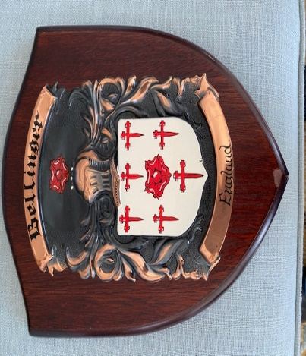

Dear Family Members, May 15, 2020

Greetings to all. We pray everyone enjoyed the 2019 Bellinger Reunion in Charlotte, N.C. **We worshipped with Family, had Fellowship and most important – had FUN!**

We want to keep everyone informed of the magnitude of effort that is required for hosting a reunion. So, we have decided to provide the following documentation for your review and information.

Items included are:

1. 2019 – 2021 Committee Member Roster and Contact Information (website)
2. 2019 Financial Report, as of May 2020, we have $93.00 in the bank (website)
3. 2019 Survey (website)

Please go to the Bellinger Family website and view the 2019 photos/videos. It Is NICE!!!

* 1. <https://thebellingerfamily.com/>

Moving forward, the next family reunion is scheduled for June 25 – 27, 2021 in Winston-Salem, N.C. More information will come from the host committee in the upcoming months.

Also, we have a guide/checklist for **“Hosting A Bellinger Reunion”** for family members that are interested in hosting a family reunion in their hometown. You can download a copy from the website effective July 1, 2020.

We are asking for each family member to contribute a love offering/donation to help offset the reunion cost. Any amount would certainly be appreciated (i.e.$10, $20, $50 or more). As a point of clarification, when you make this love offering/donation **it will not** offset your registration cost. **Again, it will not offset your registration cost.**

If you would like to get an early start paying for 2021 reunion, you can send the funds to our treasurer. An early projection for adult-only registration costs will be at least $85-$120 per adult.

You can send donations or early registration to our treasurer, Veronica Perry. Here are the options:

1)  **Zelle (using any bank that has affiliation with Zelle):**

      Email Address: [bellingerfamily2021@gmail.com](mailto:bellingerfamily2021@gmail.com)

      Account name: Veronica Perry

2)  **Cash App:**  $bellingerfamily2021 (Veronica Perry)

3) **Check via US Mail**:  Veronica Perry 2308 Elendil Lane Charlotte, NC  28269

**Note:  CHECKS ONLY should be made out to Veronica Perry, memo line: Bellinger Family Reunion**

4)  **Direct Bank Deposit:  First Citizen Bank//** Acct Name:  Veronica Bellinger Perry// Acct No. (last four digits) 6904

**Note:  If writing a check, please make out to Veronica Perry, memo line: Bellinger Family Reunion**

**Please specify on the letter, check or electronic payment, whether it is a donation/love offering or pre-registration payment.** We **“thank you”** for your contribution and steadfast commitment to the Bellinger Family Reunion.

**Please forward new home, email, and cell phone numbers to our secretary, Tiffany Williams,** [**Corinth34@gmail.com**](mailto:Corinth34@gmail.com)**. She will add your information to the family directory**.

Additionally, please have your children/youth ages 13 - 21 contact Aurelia Williams 803.306.2307 or email **- Kumahni2004@gmail.com**. She is the point of contact for our young people to share their input/ideas for the upcoming reunion.

**Now, we need your feedback/thought – We would like to re-institute the Bellinger scholarship fund for high school seniors and college seniors. Please send recommendations to Catherine Taylor (asst. secretary) via email - catherinetaylor2363@gmail.com.**

Finally, are you/family interested in joining the cell phone app **GroupMe** as a means of texting information to the entire family? Please let us know your thoughts on this idea. If you are interested, you can get a head start by downloading the app to your cell phone.

Roslyn, one of our historians, has volunteered to input the cell phone numbers.

Most important, it is truly a blessing to have a loving family that supports the reunion and continues to make a difference for all. GOD bless you all! Prayers of covering are extended to the family in midst of this coronavirus pandemic and social justice for all (Black Lives Matter). If you have any questions or concerns, please let me know.

Sincerely,

***Garvis Leak, President***

***Bellinger Family Reunion***